**ABSTRACT**

**Feedback on Training** tries to improve skills or add to the existing level of knowledge so that teacher is better equipped to do his/her present job, or to prepare him/her for a higher position with increased responsibilities. However individual growth is not an end in itself. Organizational growth needs to be increased along with individual growth.

Training refers to the teaching or learning activities done for the primary purpose of helping members of an organization to acquire and apply the knowledge skills, abilities and attitude needed by that organization to acquire and apply the same. Broadly speaking training is the act of increasing the knowledge and skill of an employee for doing a particular job.

In today’s scenario change is the order of the day and the only way to deal with it is to learn and grow. Teacher have become central to success or failure of an organization, they are the cornucopia of ideas. So, its high time the organizational realize that “Train and Retain is the mantra of new millennium”.

The project FEEDBACK ON TRAINING is developed with the intension of providing fast and accurate feedback back report on training sessions which the faculty members undertake and further the Head of the Department (HOD) can review the details and then generate the review report easily.

**TABLE OF CONTENTS**

|  |  |  |
| --- | --- | --- |
| **Sr. No.** | **Content** | **Page No.** |
| **1** | **Introduction** | **3** |
| 1.1 | Overview | 3 |
| 1.2 | Proposed System (Problem Definition) | 3 |
| **2** | **Functional Requirements** | **4** |
| 2.1 | Hardware Requirements | 4 |
| 2.2 | Software Requirements | 4 |
| **3** | **Software Requirements Specification** | **5** |
| 3.1 | Overall Description | 5 |
| 3.1.1 | Product Perspective | 5 |
| 3.1.2 | Product Function | 5 |
| 3.2 | User Classes and Characteristics | 5-6 |
| **4** | **Implementation** | **7-17** |
| **5** | **Screenshots** | **18-21** |
| **6** | **Conclusion** | **22** |
| **7** | **Future Scope and Enhancement** | **22** |
| **8** | **Bibliography** | **23** |

**INTRODUCTION**

Feedback on Training is an easy method of giving the feedback on which teachers undertake the training program and HOD can give the review on the entered details and finally the report will be generated.

* 1. **OVERVIEW:**

The project FEEDBACK ON TRAINING is developed with the intension of providing fast and accurate feedback back report on training sessions which teachers undertake and also the HOD can review the details and then generate the review report easily.

* 1. **PROPOSED SYSTEM (Problem Definition):**

**The problem in the existing: -**

Feedback on Training contents providers to focus on creating effective assessment questions and focusing on teacher’s feedback delivery. This project includes computerized review report after submission.

As the modern organizations are automated and computers are working as per the instructions, it becomes essential for the coordination of human beings, commodity and computers in a modern organization.

The teachers who are attending for training can communicate with the system through this project, thus facilitating effective implementation and monitoring of various activities of feedback on training like conducting training in institutions as per schedule and delivering to teachers. And the details of teachers who undertake training are maintained at administrator.

**2. FUNCTIONAL REQUIRNMENTS**

**2.1 HARDWARE REQUIRNMENTS:**

Any PC, mobile or tablet computer that can run a web browser and is capable of connecting to the internet.

**2.2 SOFTWARE REQUIRNMENTS:**

**2.2.1 For users:**

**Browser:** Any modern web browser.

Ideal when viewed on Firefox.

**2.2.2 For developers:**

**Operating System**: Microsoft Windows 8.1

**Front End:**  HTML, PHP, JAVASCRIPT

**Back End**: MYSQL

**Browser:**  Google Chrome

**3. SOFTWARE REQUIRNMENTS SPECIFICATION**

**3.1 Overall Description:**

This document that describes the nature of a project, software or application. In simple words, this document is manual of a project provided it is prepared before the start of a project/application. This document is also known as SRS report, software report. A software document is primarily prepared or a project, software or any kind of application.

**3.1.1 Product Perspective**

In its entirety application itself is uses basic functionalities of create, read and update operations. Any user can generate as many reports. It is developed in order to improve the training program.

**3.1.2 Product Functions:**

**3.1.2.1 Generate Report**

In the following function user (Faculty) will enter the following credentials: -

1. Name of the employee
2. Name of training program
3. Date of training
4. Presentation by faculty
5. Coverage of topics
6. Level of understanding
7. Programs and features

After entering the afore mentioned details by the user(faculty) for the following function, the review will be saved for the given training which will be reviewed by the HOD. After giving the feedback by the HOD the data will be imported from the database which will be available in the PDF format.

**3.2 User Classes and Characteristics**

For the following software the faculties would be the people who register themselves for the application.

**3.3 System Features**

It would provide the descriptive documentation of the for each feature supported by the following software. It would further have all the module listed along with any submodules and fields that defines the feature itself.

**3.3.1 Register: -** This module would help the faculties to register to generate the feedback report.

* **Input:**  Add personal details such as name, email id and password.
* **Output:**User id and password for login

**3.3.2 Login: -** To get into the Teaching module they need to enter the user’s credentials and it should match with the database.

* **Input:** User need to enter their credentials to login.
* **Output:** Users will redirect to the in the main page if users are credentials are match with

the database or it will display an error.

**3.3.3 Teacher Detail Form: -** This module would help the user to add the details of their respective department.

* **Input:**  Provide all the details of the Teacher.
* **Output:**  Details will be stored into database.

**3.3.4 Review by HOD: -** This module would help the faculties to give feedback about the training which he/she undergone through.

* **Input:**  Teacher enter the feedback
* **Output:**  Feedback will be stored into database.

**3.3.4 Generate Report: -**This module would help the user to generate a pdf report from the details filled by the faculties

* **Input:** Select the button to generate a pdf report.

**4. IMPLIMENTATION**

**4.1. Home Page**

<!DOCTYPE html>

<html lang="en">

<head>

<title>Teacher Training</title>

<meta charset="utf-8">

<meta name="viewport" content="width=device-width, initial-scale=1">

<link rel="stylesheet" href="https://maxcdn.bootstrapcdn.com/bootstrap/4.3.1/css/bootstrap.min.css">

<script src="https://ajax.googleapis.com/ajax/libs/jquery/3.3.1/jquery.min.js"></script>

<script src="https://cdnjs.cloudflare.com/ajax/libs/popper.js/1.14.7/umd/popper.min.js"></script>

<script src="https://maxcdn.bootstrapcdn.com/bootstrap/4.3.1/js/bootstrap.min.js"></script>

<link rel="stylesheet" href="https://fonts.googleapis.com/icon?family=Material+Icons">

<link rel="stylesheet" href="./styles/home.css">

</head>

<style>

body{

background-image: url(./Images/backgroundimg.jpg);

object-fit: cover;

height: 100vh;

width: 100%;

background-size: cover !important;

}

</style>

<body >

<nav class="navbar navbar-expand-sm bg-dark navbar-dark sticky-top" id="header">

<div class="navbar-brand-left" id="leftimg" href="#"><img src="Images/brand.png" class="img-responsive"></div>

<div class="head_body"><span class="navbar-text">RAMAIAH INSTITUE OF MANAGEMENT AND SCIENCES</span></div>

<ul class="navbar-nav">

</ul>

</nav>

<center>

<div>

<input type="submit" name="submit" class="btn btn-primary" value="Register" onclick="myregister()">

<input type="submit" name="submit" class="btn btn-primary" value="Login" onclick="mylogin()">

</div>

</center>

<script>

function mylogin() {

location.replace("login.php");

}

function myregister() {

location.replace("register.php");

}

</script>

</body>

</html>

**4.2 Register Page**

<?php include "./includes/header.php" ?>

<?php require "./database/dataconnect.php";

$userErr = $nameErr= $pswdErr = $emailErr = $cnfrmpswdErr= "" ;

$user = $name= $pswd = $email = $cnfrmpswd= "";

if (isset($_POST['submit'])) {

if (empty($_POST["name"])) {

$nameErr = "Name is required";

} else {

$name = $_POST["name"];

// check if name only contains letters and whitespace

if (!preg_match("/^[a-zA-Z ]*$/",$name)) {

$nameErr = "Only letters and white space allowed";

}

}

if (empty($_POST["user"])) {

$userErr = "user is required";

} else {

$user = $_POST["user"];

// check if name only contains letters and whitespace

if (!preg_match("/^[a-zA-Z0-9]*$/",$user)) {

$userErr = "only letters and numbers allowed";

}

}

if (empty($_POST["email"])) {

$emailErr = "Email is required";

} else {

$email = $_POST["email"];

// check if e-mail address is well-formed

if (!filter_var($email, FILTER_VALIDATE_EMAIL)) {

$emailErr = "Invalid email format";

}

}

if (empty($_POST["pswd"] )) {

$pswdErr = "pswd is required";

} else {

$pswd = $_POST["pswd"];

}

if (empty($_POST["cnfrmpswd"] )) {

$cnfrmpswdErr = "pswd is required";

} else {

$cnfrmpswd = $_POST["cnfrmpswd"];

}

if($pswd==$cnfrmpswd)

{

$pswd=$_POST["pswd"];

}else{

$pswdErr = "Does not match";

}

}

if(empty($user) ||empty($name) || empty($pswd) ||empty($cnfrmpswd) || empty($email)){

}

else

{

$insert_data = "insert into admin(name,username,email,password) values('$name','$user','$email','$pswd')";

$con->query($insert_data);

header("location: login.php");

}

?>

<div class="maindiv">

<div class="signup">

<center><h3 class="signup_header">Signup</h3></center>

<form action="" method ="POST" >

<div class="row">

<div class="input-field col s6">

<label class="signup_text">Name</label><br>

<input type="text" class="form-control" name="name" placeholder="Enter name" value="<?php echo $name;?>">

<span class="form-text text-muted" id="error">*

<?php echo $nameErr;?>

</span>

</div>

<div class="input-field col s6">

<label class="signup_text">Username</label><br>

<input type="text" class="form-control" name="user" placeholder="Enter username" value="<?php echo $user;?>">

<span class="form-text text-muted" id="error">*

<?php echo $userErr;?>

</span>

</div>

</div>

<label class="signup_text">EmailId</label><br>

<input type="text" class="form-control" name="email" placeholder="Enter email" value="<?php echo $email;?>">

<span class="form-text text-muted" id="error">*

<?php echo $emailErr;?>

</span>

<div class="row">

<div class="input-field col s6">

<label class="signup_text">Password</label><br>

<input type="password" class="form-control" name="pswd" placeholder="Enter password" value="<?php echo $pswd;?>">

<span class="form-text text-muted" id="error">*

<?php echo $pswdErr;?>

</span>

</div>

<div class="input-field col s6">

<label class="signup_text">Confirm Password</label><br>

<input type="password" class="form-control" name="cnfrmpswd" placeholder="Confirm Password" value="<?php echo $cnfrmpswd;?>">

<span class="form-text text-muted" id="error">*

<?php echo $cnfrmpswdErr;?>

</span><br>

</div>

</div>

<div class="row">

<div class="input-field col s6">

<input type="submit" name="submit" class="btn btn-primary btn-lg btn-block" value="Register">

</div>

<div class="input-field col s6">

<button type="button" name="cancel" class="btn btn-primary btn-lg btn-block" onclick="window.location.href='home.php'">Cancel</button>

</div>

</div>

</form>

</div>

</div>

<!--

<script type="text/javascript">

$("#cancel").function()

</script> -->

**4.3 Teacher Login Page**

<?php include "./includes/header.php" ?>

<?php require "./database/dataconnect.php";

$error = "";

if (isset($_POST['submit'])) {

$user = $_POST['user'];

$pswd = $_POST['pswd'];

$email = $_POST['user'];

if(empty($user) || empty($email) || empty($pswd)){

$error = "Please enter the details";

}

else{

$search_data = "select *from admin where email = '$email' and password='$pswd'";

$search_result = $con->query($search_data);

if($search_result->num_rows > 0)

{

header("location: feedback.php");

}

// $insert_data = "select (username,email,password) values('$user','$email','$pswd')";

// $con->query($insert_data);

else{

echo 'Incorrect Coredentials';

}

}

}

?>

<div class="maindiv">

<div class="signup">

<center><h2 class="signup_header">Login</h2></center>

<form action="" method ="POST" >

<div class="row">

<div class="input-field col">

<label class="signup_text">Email</label>

<input type="text" name="user" class="form-control" placeholder="Enter email"><br>

</div>

</div>

<div class="row">

<div class="input-field col">

<label class="signup_text">password</label>

<input type="password" name="pswd" class="form-control" placeholder="Enter password"><br>

</div>

</div>

<input type="submit" name="submit" class="btn btn-primary" value="Login">

<button class="btn btn-primary"><a href="register.php" style="color: white;">New to Login</a></button>

<!--<input type="submit" name="submit" class="btn btn-primary btn-lg btn-block" value="Login">-->

<!--<input type="submit" name="submit" class="submit_btn" value="Login">-->

<?php echo "<div>$error</div>" ?>

</form>

</div>

</div>

**4.4 Feedback Page**

<?php include "./includes/header.php"?>

<?php require "./database/dataconnect.php";

$error = "";

$reterive_data = "select * from feedback order by eid DESC limit 1";

$store = $con->query($reterive_data);

$rslt = $store->fetch_assoc();

// print_r($rslt);

if(isset($_POST['submit'])) {

$exec = $_POST["presentation"];

$topic = $_POST["topic"];

$level = $_POST["level"];

$res = $_POST["res"];

$future = $_POST["future"];

$recc=$_POST["recc"];

if(empty($exec) || empty($topic) || empty($level) || empty($res) || empty($future)||empty($recc)) {

$error = "Please fill all the details";

}

else

{

$insert_data = "update feedback set presentation='$exec',topic='$topic',level='$level',res='$res' ,future='$future',recc='$recc' where eid=".$rslt['eid'];

$res = $con->query($insert_data);

if(!$res)

{

echo "$con->error";

}

echo "<script type=\"text/javascript\">window.alert('Data Entered');

window.location.href = './home.php';</script>";

}

}

?>

<div class="maindiv">

<center>

<label class="heading"> Presentation by faculty</label>

</center>

<div class="nxtwindow">

<form action="" method="POST">

<label class="exec">Excellent:</label>

<input type="radio" name="presentation" value="Good">Good

<input type="radio" name="presentation" value="Average">Average

<input type="radio" name="presentation" value="Poor">Poor

<input type="radio" name="presentation" value="very poor">very poor

<br>

<label class="topic">Coverage of topic: </label><br>

<textarea name="topic" class="txtarea"></textarea><br>

<label class="level">Your level of understaning</label>

<input type="radio" name="level" value="Good">Good

<input type="radio" name="level" value="Average">Average

<input type="radio" name="level" value="Poor">Poor

<br>

(Specify briefly reasons)<br>

<textarea name="res" class="txtarea"></textarea><br>

<label class="future">Do you want such programs in future:</label>

<input type="radio" name="future" value="Yes">Yes

<input type="radio" name="future" value="Poor">No

<br>

<label class ="recommend">if Yes, what topics would you recommend?</label><br>

<textarea name="recc" class="txtarea"></textarea><br>

<input type="submit" name="submit" value="Submit">

</form>

</div>

</div>

**4.5 Hod Page**

<?php include "./includes/header.php" ?>

<?php require "./database/dataconnect.php";

$error = "";

$tabledata = array();

$retrieve_data = "select * from feedback";

$result = $con->query($retrieve_data);

if($result->num_rows > 0)

{

while($row = $result->fetch_assoc())

{

$tabledata[] = $row;

}

}

?>

<div class="row">

<div class="input-field col s12">

<table>

<tr>

<th>Employee Name</th>

<th>Department</th>

<th>Training</th>

<th>Organization</th>

<th>Date</th>

<th>Presentation</th>

<th>Topic</th>

<th>Level</th>

<th>Reason</th>

<th>Future</th>

<th>Recommended</th>

</tr>

<?php

foreach ($tabledata as $value) {

echo "<tr>";

echo "<td>" . $value['empname'] . "</td>";

echo "<td>" . $value['dept'] . "</td>";

echo "<td>" . $value['training'] . "</td>";

echo "<td>" . $value['org'] ."</td>";

echo "<td>" . $value['date'] ."</td>";

echo "<td>" . $value['presentation'] . "</td>";

echo "<td>" . $value['topic'] . "</td>";

echo "<td>" . $value['level'] . "</td>";

echo "<td>" . $value['res'] . "</td>";

echo "<td>" . $value['future'] ."</td>";

echo "<td>" . $value['recc'] ."</td>";

// echo "<td>" ."<input type='button' name='btn' value='review' class='review_form_btn'>". "</tr>";

echo "<td><button><a href='hod.php?eid=". $value['eid'] ."'>review</a></button></td>";

echo "</tr>";

}

?>

</table>

</div>

</div>

<!-- Review Box -->

<?php if (isset($_GET['eid'])): ?>

<div id="display" class="lightbox">

<div class="review">

<form action="hodreview.php?eid=<?= $_GET['eid']?>" method="POST" class="design">

<label class="understand">a) Understanding</label><br>

<input type="radio" name="understand" value="Good">Good

<input type="radio" name="understand" value="Average">Average

<input type="radio" name="understand" value="Poor">Poor<br><br>

<label class="Job">b) Application at Job:</label><br>

<input type="radio" name="Job" value="well">Applies Well

<input type="radio" name="Job" value="eviden">No evidence of application

<input type="radio" name="Job" value="Lack">Exhibits Lack of understanding

<input type="radio" name="Job" value="Knowledgeable">Indifferent though Knowledgeable <br/><br/>

<label class="remarks">c) General Remarks:</label><br>

<textarea name="remarks" class="txtarea"></textarea><br>

<input type="submit" name="sub" value="Reigster"/>

</form>

</div>

</div>

<?php endif; ?>

<script>

$(document).ready(function()

{

// console.log("working");

$(".lightbox").hide();

$(".review_form_btn").click(function(){

// console.log("button clicked");

$(".lightbox").show();

});

})

</script>

**4.6 Hod Review Page:**

<?php include "./includes/header.php"?>

<?php require "./database/dataconnect.php";

$error = "";

if(isset($_POST['sub'])) {

$understanding = $_POST["understand"];

$application = $_POST["Job"];

$general = $_POST["remarks"];

$eid=$_GET['eid'];

if(empty($understanding) || empty($application) || empty($general)) {

$error = "Please fill all the details";

}

else

{

$insert_data = "update feedback set understanding='$understanding',application='$application',general='$general' where eid=".$eid;

$res = $con->query($insert_data);

if(!$res)

{

echo "$con->error";

}

header('location: generatepdf.php?eid='.$eid);

}

}

?>

**4.7 Pdf Page**

<?php

require_once("./database/dataconnect.php");

$retrieve_data = "select * from feedback where eid=" .$_GET['eid'];

$result = $con->query($retrieve_data);

$rslt = [];

while($row = $result->fetch_assoc())

$rslt[] = $row;

require "./fpdf181/fpdf.php";

$pdf = new FPDF();

$pdf->AddPage();

$pdf->SetFont('Courier','B',14);

$y_axis = 30;

$pdf->Image('./Images/logo.png',5,5,-1400);

$pdf->Text(80,25,'FEEDBACK ON TRAINING');

$pdf->Text(80,27,'--------------------');

foreach($rslt as $row) {

$y_axis += 10;

$pdf->SetFont('Courier','',10);

$pdf->Ln();

$pdf->Text(15,50,'Name of the Employee: '.$row['empname']);

$pdf->Text(130,60,'Department: '.$row['dept']);

$pdf->Text(15,60,'Name of Training Program: '.$row['training']);

$pdf->Text(15,70,'Organization in which training undertaken: '.$row['org']);

$pdf->Text(130,70,'Date of Training: '.$row['date']);

$pdf->SetFont('Courier','B',12);

$pdf->Text(15,80,'Feedback: ');

$pdf->SetFont('Courier','',10);

$pdf->Text(15,90,'a) Presentation by Faculty: '.$row['presentation']);

$pdf->Text(15,100,'b) Coverage of Topics: '.$row['topic']);

$pdf->Text(15,110,'c) Your level of Understanding: '.$row['level']);

$pdf->Text(15,115,' (specify briefly reason)' );

$pdf->Text(15,125,'d) Do you want such programs in future: '.$row['future']);

$pdf->Text(15,130,' (if yes what topic would you recommend)');

$pdf->SetFont('Courier','B',10);

$pdf->Text(15,140,' -------------------------------------------------------------------------------');

$pdf->SetFont('Courier','B',11);

$pdf->Text(15,149,' HOD Evaluation of the effectiveness of training (to be filled in about');

$pdf->Text(15,154,' three months)');

$pdf->SetFont('Courier','',10);

$pdf->Text(15,170,'a) Undersatnding: '.$row['understanding']);

$pdf->Text(15,180,'b) Application at Job: '.$row['application']);

$pdf->Text(15,190,'c) General Remarks: '.$row['general']);

$pdf->SetFont('Courier','B',10);

$pdf->Text(15,230,' (Signature of Faculty)');

$pdf->Text(140,230,' (Signature of HOD)');

$pdf->SetFont('Courier','B',10);

$pdf->Text(15,233,' --------------------------------------------------------------------------------');

}

$pdf->Output();

?>

**5. SCREENSHORTS**



**Figure 5.1**

**Home Page:** This is the main page were teacher and HoD will login to give their review.

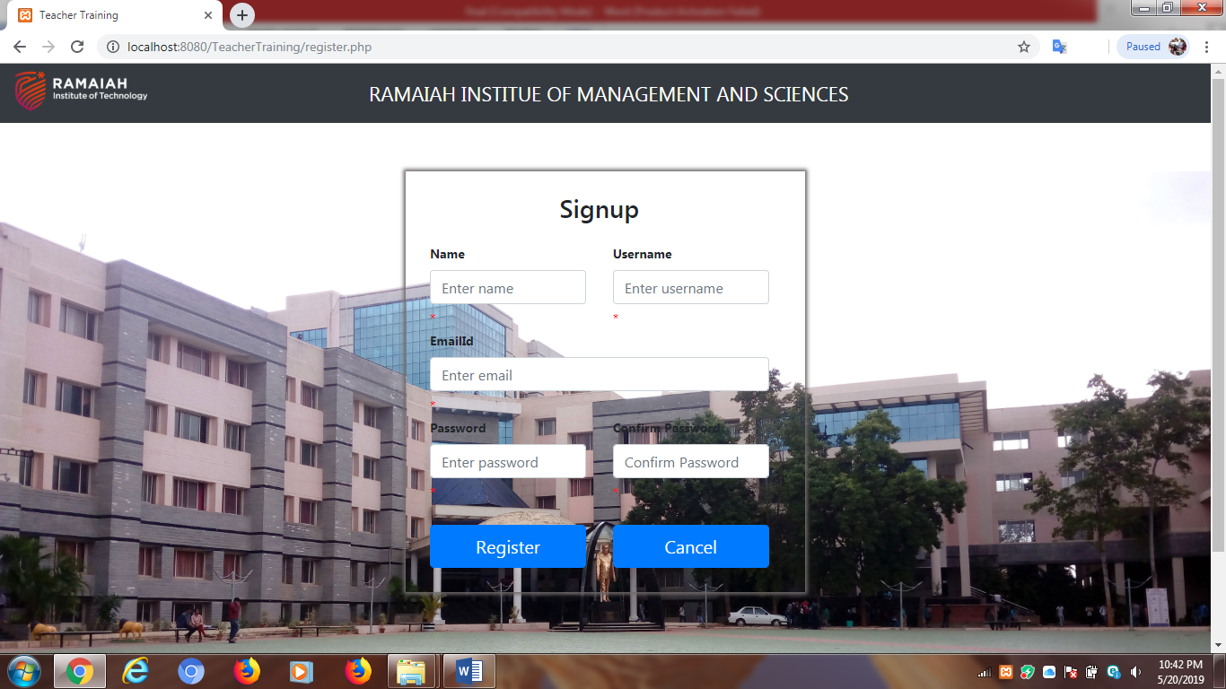

**Figure 5.2**

**Signup page:** It prompts teacher to enter the details and will help in registering.

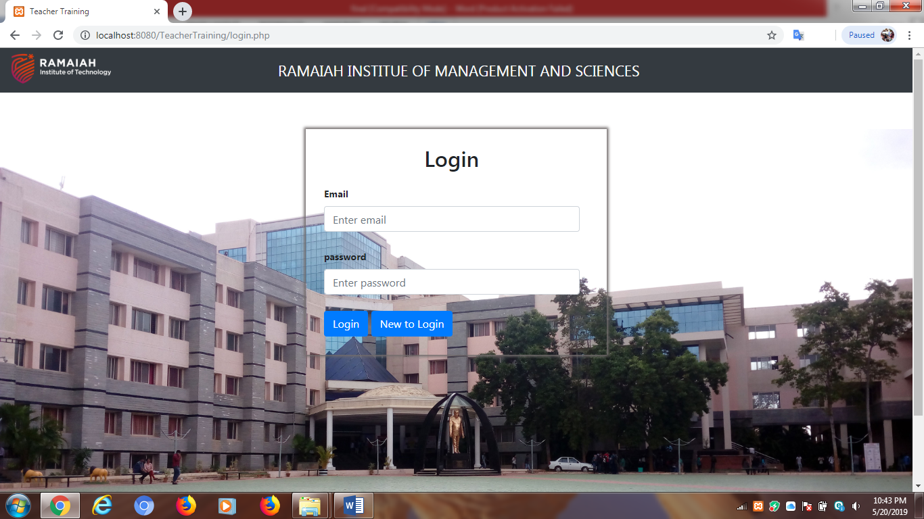

**Figure 5.3**

**Login Form:** This page will take a secured Mail ID along with passwords for authenticating the individual.

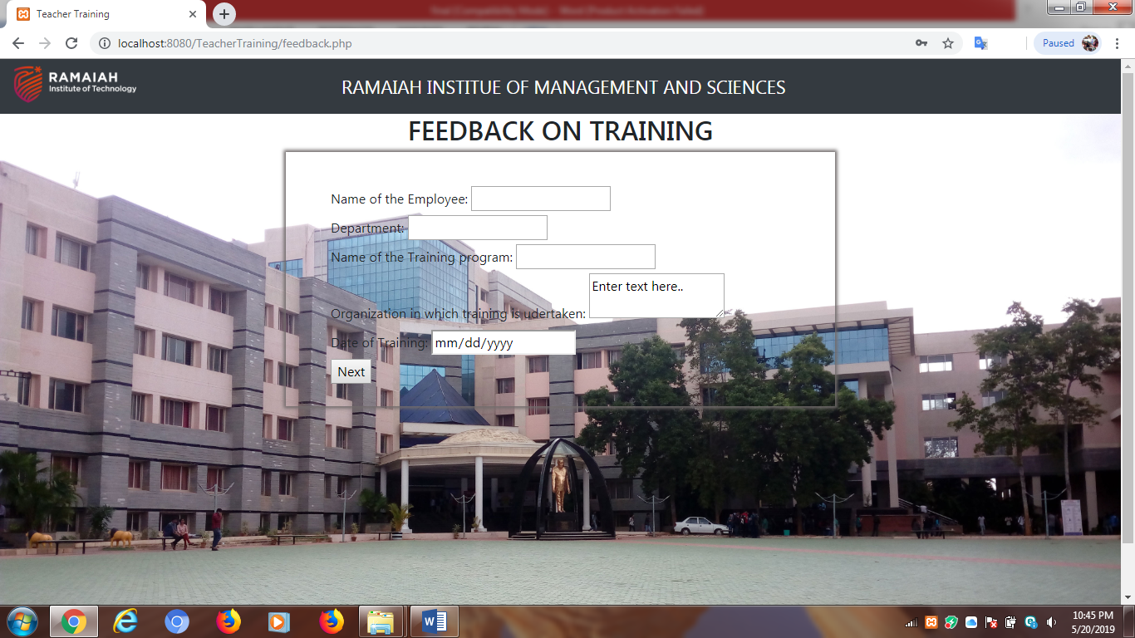

**Figure 5.4**

**Feedback on Training:** This page will be prompted to enter the basic details of the faculties and about the training programme they have attended.

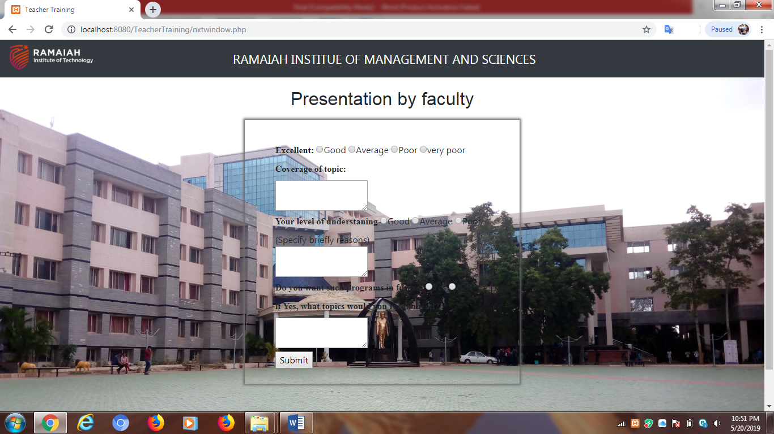

**Figure 5.5**

**Presentation by Faculty:** This page prompts to enter the review (feedback) details of the training programme.

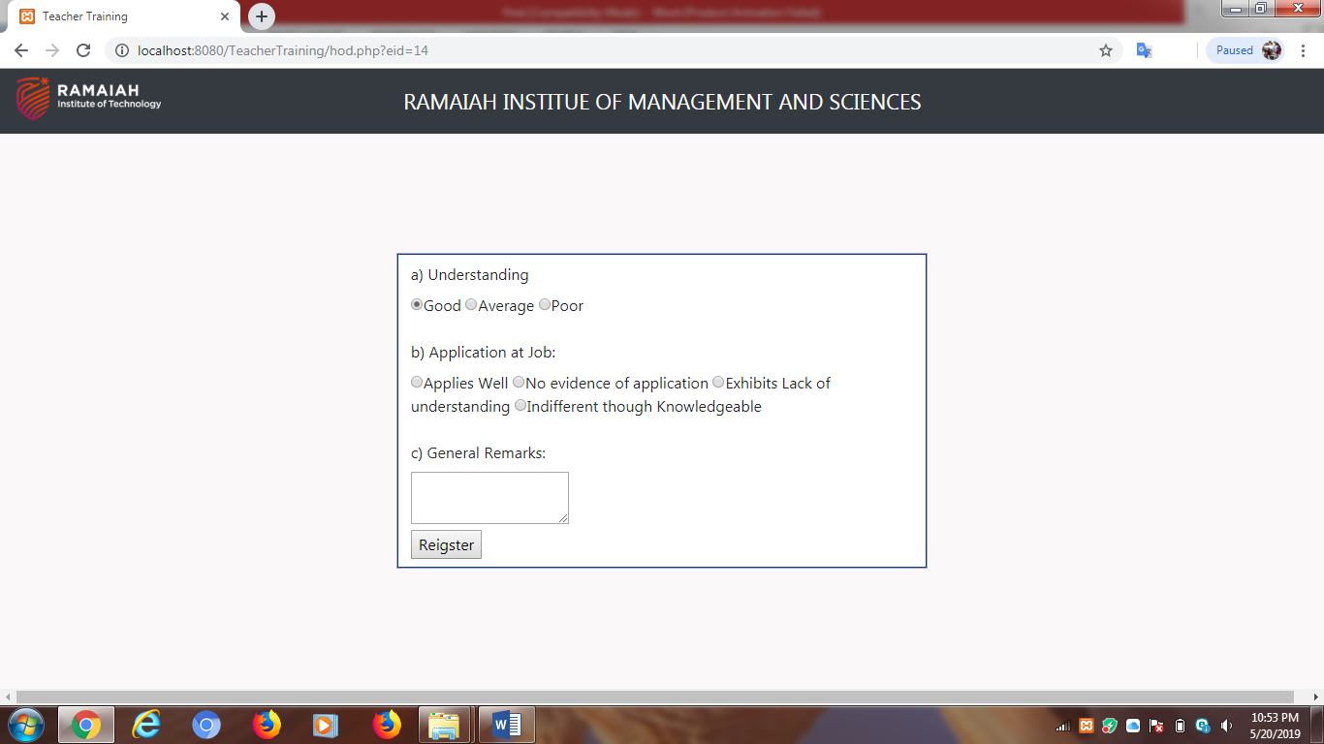

**Figure 5.6**

**HOD Review:** This page helps HOD to evaluate the training process and give their review back to those particular feedback which have been registered.

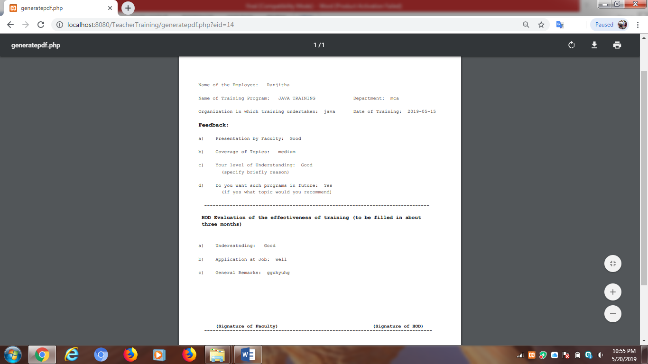

**Figure 5.7**

**Feedback Form (PDF Generated):** This page helps to generate a PDF report with the information given by faculty and also by the HOD related to the feedback on training.

**6. CONCLUSION**

We all know that training and development are important for an organization to develop the employee. Taking into considerations we design this application to improve the training program, so that the training can be improved in a better way by keeping the review of faculties attended by them.

Employees are expected to develop themselves continuously in an organization. When the employees in an organization are developed from time to time with all updated knowledge, then definitely that organization will grow to a greater height as well as faculty will be able to improve their teaching skills on the basis of training given to them. Still training is required due to rapid technological up gradation and change in working methods every day, which help the faculties to understand the new technology which is on-going in the current Industry.

Both employees and faculties are concerned with developing future skills and managing careers. Companies want a work force that is motivated and productive, has up-to-date skills, and can quickly learn new skills to meet changing faculties needs. Faculties want to develop skills that not only are useful for their teaching profession but also are congruent with their personal interests and values. Faculties are interested in developing skills that can help them remain employable with either their current employer or a future one.

**7. FUTURE SCOPE AND ENHANCMENTS**

As soon as the teachers give their review on the training process they have attended, it should generate a notification to the HOD, saying that there is a new review on the feedback, so that HOD will be able to evaluate it as soon as possible.

When the HOD give their review for each feedback received, then that feedback should be sent back to that faculty who has given their review on the training, so that it can help in betterment of training sessions held.

This application is designed and used only by MCA department, it can be implemented and used in a wider range and can be used for the entire college to each department individually. Each department teacher can give their review on the training they have undergone and that department HOD can also give their review individually to that faculty.

This system will also reduce the manual work done by the faculties and also by HOD, by providing a systematic approach via this application.

**8. BIBLIOGRAPHY**

1. **PHP** - <https://www.w3schools.com/php/>
2. **BOOTSTRAP** - <https://getbootstrap.com/>
3. **GENERATE PDF:** - <http://www.fpdf.org/>